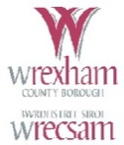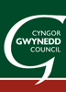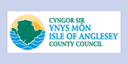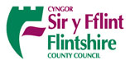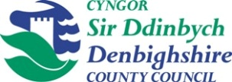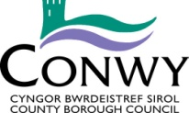 

The six Local Authorities across North Wales and BCUHB have been working together for the last year on both the Frailty Programme and the Integrated Assessment Framework. We would like to invite you to an exciting workshop which explores the What Matter’s conversation, the language of independence and Frailty and what keeps you well in the community. We would like to engage with a large and varied group across North Wales at our joint workshop to be held on October 2nd 9am-12.30pm at the Optic Centre in St Asaph.

**Programme**

9am Welcome

9.15 What Matters? (Integrated Assessment Framework) speaker to be confirmed

9.30 The Frailty Programme – Olwen Williams

9.45 Co-Production – Pam Luckock and Fran O’Hara

10.00 Tea and Coffee

10.15 Workshops:

* The language of frailty and independence
* What keeps you well in your community
* The what matters conversation – tell us your experience

11.45 Feedback

* The language of frailty and independence
* What keeps you well in your community
* The what matters conversation – tell us your experience

12.15 Closing remarks

12.30 Close.